Criar Controllers e Templates

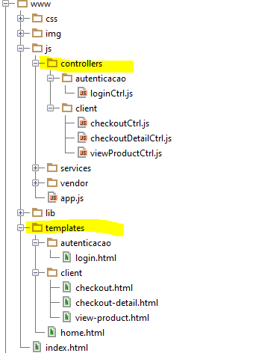

Chamar na Index.html

*<!-- your app's js -->*<**script src="js/app.js"**></**script**>  
  
*<!-- CONTROLLERS -->*<**script src="js/controllers/autenticacao/loginCtrl.js"**></**script**>  
<**script src="js/controllers/client/checkoutCtrl.js"**></**script**>  
<**script src="js/controllers/client/checkoutDetailCtrl.js"**></**script**>  
<**script src="js/controllers/client/viewProductCtrl.js"**></**script**>

Rotas

*/*CLIENT*/*.state(**'client'**, {  
 **abstract**: **true**,  
 **url**:**'/client'**,  
 **template**:**'<ui-view/>'**})  
.state(**'client.checkout'**, {  
 **url**: **'/checkout'**,  
 **templateUrl**: **'templates/client/checkout.html'**,  
 **controller**: **'ClientCheckoutCtrl'**})  
.state(**'client.checkout_detail'**, {  
 **url**: **'/checkout/detail/:index'**,  
 **templateUrl**: **'templates/client/checkout-detail.html'**,  
 **controller**: **'ClientCheckoutDetailCtrl'**})  
.state(**'client.view_product'**, {  
 **url**: **'/view_products'**,  
 **templateUrl**: **'templates/client/view-product.html'**,  
 **controller**: **'ClientViewProductCtrl'**})